MAIN PAGE
WPC (WOOD PLASTIC COMPOSITE) SIDING & SOFFIT
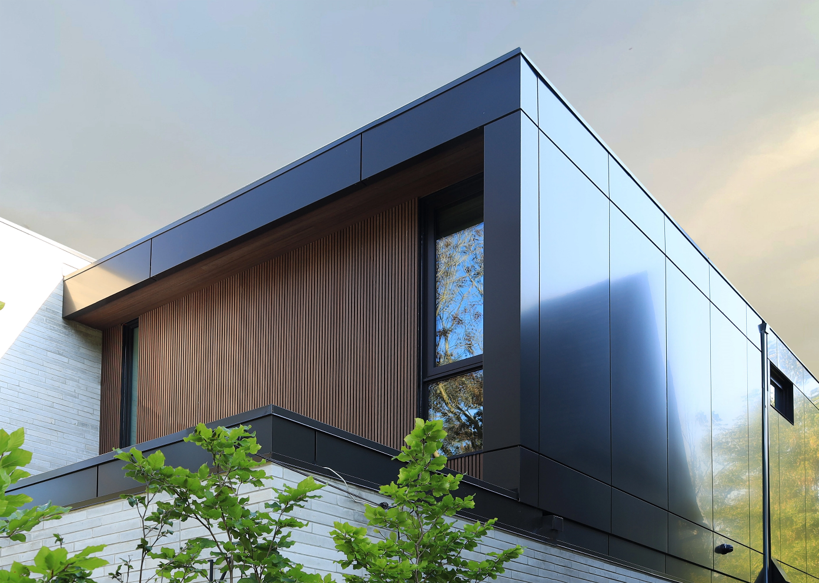
Industrial / Residential / Commercial / Agricultural
WPC Boards — Where Natural Beauty Meets Modern Innovation
WPC board is a type of composite material that combines wood fibers with thermoplastics. Compared to traditional wood products such as MDF boards, WPC boards have many advantages and can be used for various applications.
WPC (Wood Plastic Composite) board is a next-generation material that merges wood fibers with thermoplastics to create a durable, weather-resistant, and low-maintenance solution for a variety of applications. Unlike traditional wood-based products like MDF, WPC offers superior strength, longevity, and adaptability, making it an excellent choice for both interior and exterior projects.

Why Choose WPC?

Built to Last
WPC boards are engineered to resist moisture, rot, warping, and insect damage — making them an ideal choice for demanding environments, from harsh winters to humid summers.

Virtually Maintenance-Free
Forget constant sanding, sealing, and repainting. WPC retains its appearance with minimal upkeep, saving time and maintenance costs over the long term.

Sustainably Engineered
Made from recycled materials, WPC is an environmentally conscious alternative to conventional lumber — without compromising on durability or beauty.

Versatile for Any Project
Whether you’re designing sleek outdoor cladding, stylish indoor wall panels, or functional fencing and decking, WPC delivers consistent performance with a high-end finish.

Enhanced Aesthetics
Thanks to advanced manufacturing techniques, WPC boards replicate the natural grain, warmth, and colour variations of real wood — all while offering a broader selection of tones and finishes that stay vibrant for years.

The Ideal Upgrade to Traditional Wood & MDF
While MDF swells, weakens, and deteriorates in moisture-prone environments, WPC remains stable and reliable, even in exposed exterior conditions. It’s the smart solution for designers, builders, and homeowners who demand more from their materials.
Speak with an Expert Get personalized advice and expert guidance to achieve your project goals with confidence.
WPC SIDING & SOFFIT (PREVIEW)

WPC Shiplap Siding & Soffit Panels- ICON
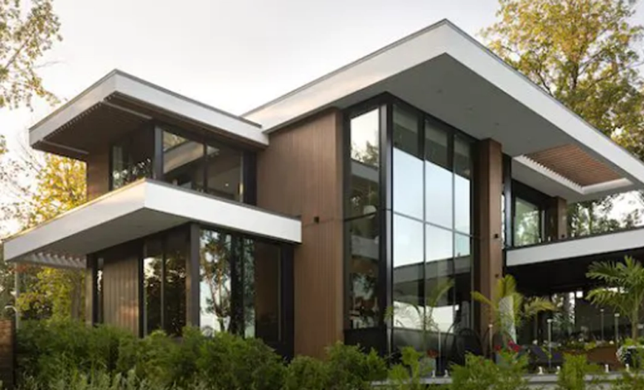
Timeless Charm, Built-In Performance
Shiplap is a versatile wooden board widely used in both interior design and construction. Recognized for its distinct rabbeted edges, this design allows the boards to overlap seamlessly, creating a tight seal that enhances both aesthetics and functionality........ (Learn More / Expand)

ENGINEERED WOOD SIDING & SOFFIT (EXPANDED)
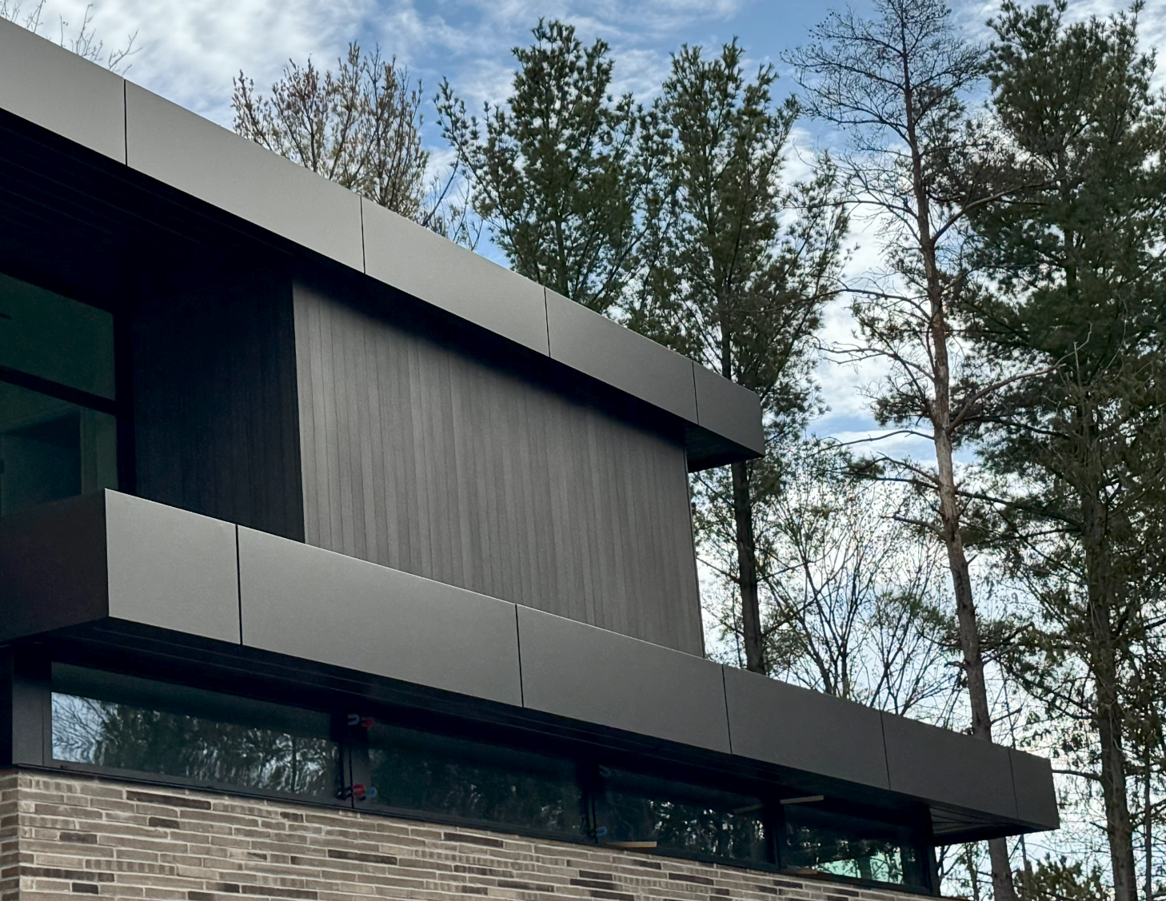
Expanded … Timeless Charm, Built-In Performance
Shiplap is a versatile wooden board widely used in both interior design and construction. Recognized for its distinct rabbeted edges, this design allows the boards to overlap seamlessly, creating a tight seal that enhances both aesthetics and functionality.
Originally used in shipbuilding to keep water out, shiplap’s durability and weather resistance made it a popular choice for home construction, particularly in Western Canada and Northern Ontario. Today, it remains a sought-after design element, adding texture, warmth, and character to modern and rustic spaces alike.

Product Details:

Shiplap (Flat)
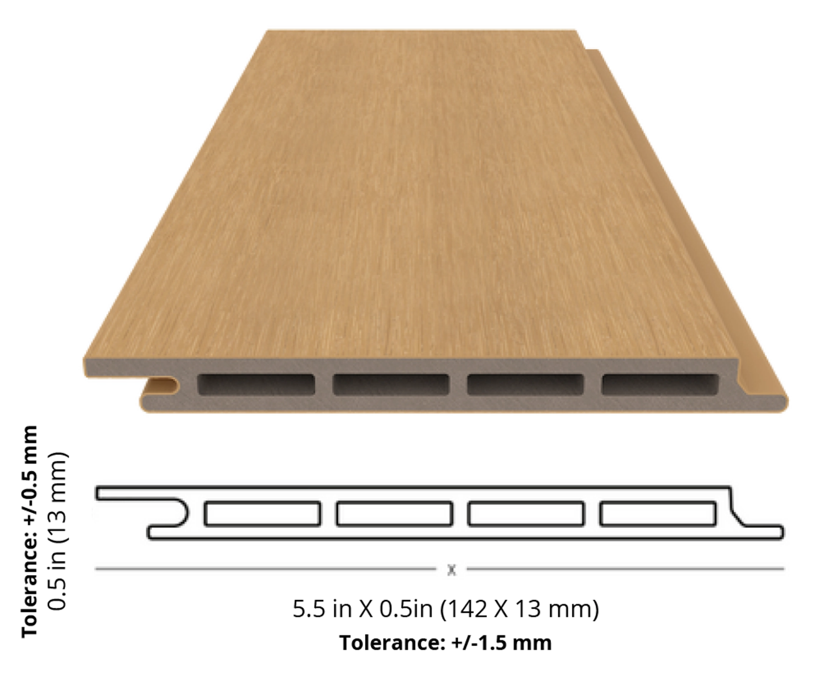

Finish: Brushed
Available Lengths: 10 ft, 12 ft and 16 ft
Profile Dimensions: 5.5” wide × 0.5” thick
Installation Options: Horizontal, Vertical and Soffit applications

Trims
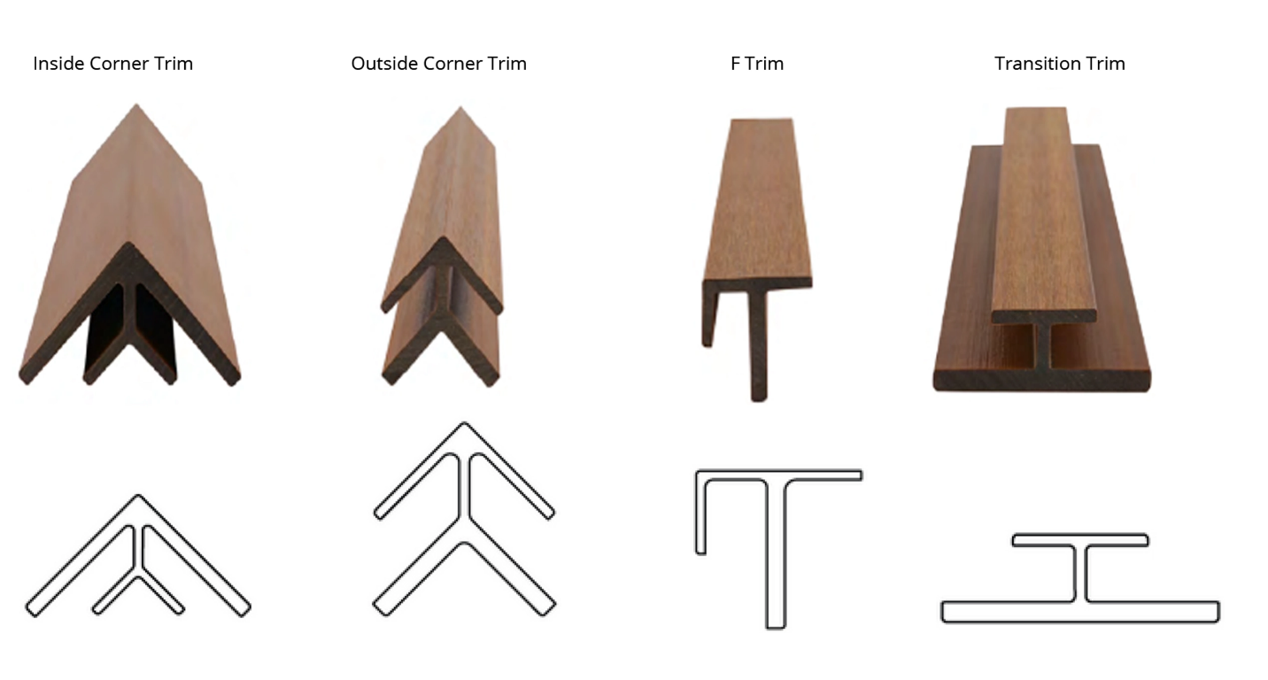
Finish: Brushed
Available Lengths: 10 ft and 16 ft

Available Finishes

